Turkey is ready to collaborate in “any area” with Venezuela

“Turkish companies are ready to come to Bolivar’s land”, affirmed the Turkish Ambassador to Caracas, Muhsin Kiliçaslan, who recognized that the Nation’s president has a great interest in cooperating with all the planet

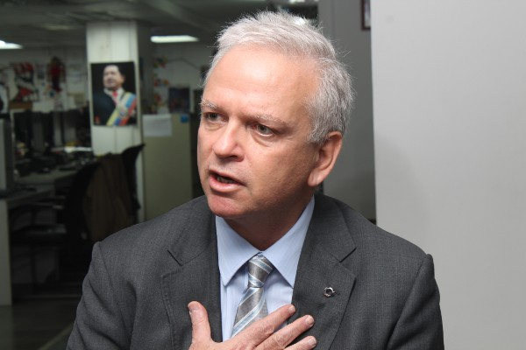

Venezuela has come closer to Turkey for multiple reasons. The first, without a doubt, is a multipolar policy executed and defended by the Bolivarian Revolution . An example of such is that Turkish entrepreneurs are ongoing an ambitious development of the Gran Misión Vivienda in Vargas state.

On his visit to the editorial office of Correo del Orinoco, Ambassador Muhsin Kiliçaslan, ratified that Turkey is ready to collaborate with Bolivar’s land “in any area”

On the economic aspect “We must discover the possibilities. There is a big potential for trade exchange”, he emphasized. Last year, trade between two countries increased by 90%. In the three first months of 2012 the increase exceeded 100%, calculated the spokesman.

“We are very good in construction and not only of houses. We are very good in building infrastructure. Turkish construction companies are active in 90 countries” he said.

The only Turkish construction project being executed in Latin America is the one in Playa Grande, Varga’s State, through a bi-national agreement that contemplates benefits for more than 1400 families on its first stage.

-Can Turkey do other developments with Venezuela?

-Of course. Turkish companies are ready to come here.

-Are you satisfied with the housing development in Vargas?

-Of course (laughs) we began in November last year. There was nothing there. Now you can see the buildings and we will finish them in August this year, with the road system included. We are working on a project, under the leadership of president Chávez, of “Petroleum for Houses”. We are cooperating very well with the Ministry of Foreign Affairs and Ministry of Petroleum and Energy, and of course, with PDVSA.

The Diplomat recalled that past September a Turkish trade delegation visited Venezuela, “the biggest that has ever been in Latin America”, with businessman from the public and private sectors. The next meeting will be held in Turkey, after the Venezuelan presidential elections.

One of the areas, according to Kiliçaslan, that would like to be developed is the establishment of an aerial route Caracas-Istanbul.

Regarding the international affairs, evaluated the Ambassador, Venezuela and Turkey, “have been supporting each other”, but “we can develop a lot more”.

WITH TURKEY ON THE COMPASS

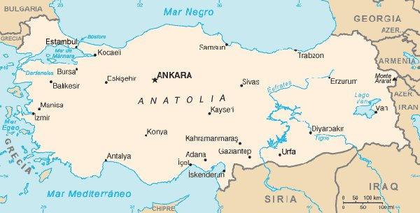

-Why is there now a rapprochement of Turkey to Latin America?

-There is larger amount of responsibilities in our foreign policy, and we have to cooperate a lot more with countries that had been set aside before. We are cooperating intensively with Brazil, for example. In the last years we had projects with Brazil, related with Iran. Now there is a larger cooperation with Latin America. Turkey is politically and economically stronger, and there are much more areas for cooperation. We have to understand, as well, Latin American and its current political situation.

“Latin America also discovered Turkey. Sometimes I am asked ‘Where is Venezuela?’ and I answer ‘It’s the country of Chávez’ there they realized, where Venezuela is”.

However, the diplomat believes his country is not well positioned in Venezuelan Soil.

-Why do you think is the reason for this?

-We were not active in the region. There were no significant cultural, economical or political activities. There was something, but never enough. Today there is an economic activity through Gran Misión Vivienda Venezuela. This is an opportunity to show the Venezuelan people that we can work in a very effective and fast way, so can Venezuela realized they can work with us in economic terms.

-There are changes going on in Latin America. In Venezuela, Peru, Bolivia, Ecuador. We can speak of a progressionist block. Has this facilitated the rapprochement with Turkey?

-I believe that Latin America is very interested in developing its relations with other parts of the world. President Chávez is very interested in developing relations with all parts of the world. The existence of Telesur, for example, it can reach Turkey and that is a sign that Venezuela, and Latin America, are interested in other regions. In times of globalization we have to be interested in one another, we are coming closer.

-Has the compass in Latin America changed its direction to Turkey?

-Yes. Now everybody see Turkey in a different manner, because we have a proactive Foreign Policy; it is not limited exclusively to the countries near us, as the countries of the Caucasus or the Middle East. We are interested in all corners of the world. For example, in the last 2 years we have opened more than 20 new embassies, only in Africa. We opened 3 embassies in Latin America and also in Asia.

Accoding to Kılıçaslan, “everybody is looking at Turkey with different eyes. We were members of the UN’s Security Council, and the world could see at that moment that we work for peace, and that our goals are peace and stability. Our interests are: peace, stability and the development of cooperation”.

MORE TOURISM

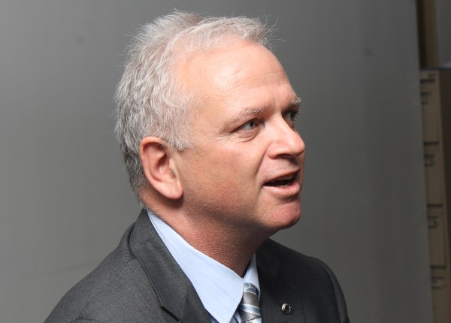

Turkey “is the 6th or 7th country in the world that received the largest amount of tourists. Last year we received 31 million visitors. Do you know how many of them are from Venezuela? Only eight thousand and the majority comes from other countries rather than Venezuela directly”, said the diplomat.

The scenario is not better when look at in the opposite direction, being Istanbul-Caracas. “Only workers and some artist come”, detailed Kiliçaslan.

-This touristic development, on what will depend on? What is needed?

-I believe we must bring our businessmen so they can understand better. We have a great experience with tourism and we can share it.

For Kiliçaslan, a good example on what can be done in the tourism field, is what happened in the island of Rodos, that more than 20 years ago had more visitors Thank all of Turkey. “You can imagine the development we did in the last two decades to promote the sector” said the Ambassador.

Currently Turkish entrepreneurs “are operating hotels in all parts of the world” highlighted Kiliçaslan. In Tripoli, Libya’s capital, only two five star hotels remained opened during the “NATO attacks in 2011” (Bu ifade Sayın Büyükelçi tarafından kullanılmamıştır). “The two hotels are Turkish”, he pointed.

MUSIC FOR PEACE

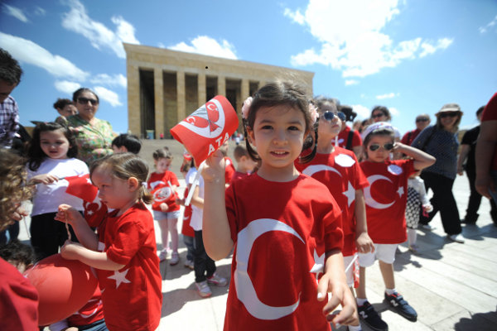

Muhsin Kiliçaslan reminded that last year, the Simón Bolívar Youth Orchestra gave two concerts in Istanbul. “During two or three days, Venezuela was all around the Turkish televisions. Maestro José Antonio Abreu and Gustavo Dudamel have a great load of fans in Turkey”, reported the diplomat.

In the Turkish nation there’s a similar organization to the criollo system of orchestras, “very small”, but with similar principles; the Ambassador believes that cooperation between the two systems can be made under one idea: Music for Peace. The Turkish side “wants to develop their system according to the principles of the Venezuelan El Sistema”.

The official was very impressed by the music and arts of Venezuela. “In everywhere, wherever we go, there are masterpieces. You have a special taste” he affirmed.

“If we bring closer the artist, the businessmen and the population, we will find many fields to work”, he assured.

-In the music field, would you propose an agreement?

-We are interested in cooperation with Venezuela in this field. We want to create a youth Turkish-Venezuelan orchestra. Turkish Civil society and Government are interested.

“WE ARE A BRIDGE BETWEEN CULTURES”

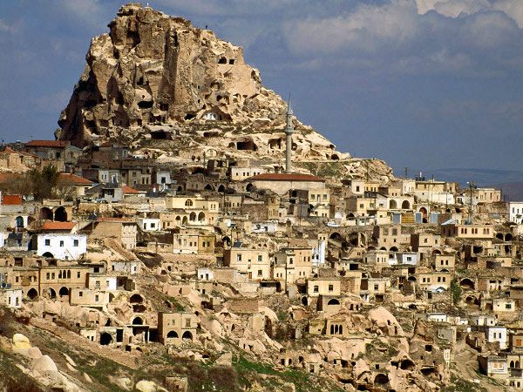

-How do you want Venezuela to see Turkey? Other countries criticize Turkey.

-I would them to see Turkey as it is. My Minister is on different places 300 days a year, to assure peace and to solve problems. It is important for us, they should see us as we are: between cultures. We are a bridge between cultures. We want to have Christians and Muslims together.

Ambassador Muhsin Kiliçaslan reiterated that “it is an initiative of our Prime Minister (Recep Tayyip Erdoğan) the Alliance of civilizations. In Venezuela you don’t have that problem, but in other parts of the world it is a serious one”

The diplomat deplored the existence of Islamophobia and highlighted that “if there’s phobia against Muslims, you get an answer. We respect religions and the beliefs of the entire world and also the political opinions, we are trying to change our society” with reforms to the judicial and penitentiary systems.

T/ Vanessa Davies

F/ Girman Bracamonte

